Mastering Big Data with Apache Pig
.Section 1: Introduction to Apache Pig
What is Apache Pig?
In the Hadoop ecosystem, data is massive and often messy. To analyze this data, developers originally had to write complex Java programs called MapReduce. Apache Pig is a high-level platform that sits on top of Hadoop. It allows you to write simple scripts using a language called Pig Latin, which the platform then translates into complex Hadoop jobs.
Why Pig? (Pig vs. MapReduce)
Imagine you want to make a cup of coffee.
- MapReduce is like building the espresso machine, roasting the beans, and plumbing the water line yourself just for one cup.
- Apache Pig is like using a modern coffee pod machine. You provide the "pod" (your script), and the machine handles the complex mechanics for you.
Key Advantages:
- Conciseness: A task that takes 200 lines of Java code in MapReduce can often be done in just 10 lines of Pig Latin.
- Speed: You spend less time coding and more time analyzing data.
- No Java Required: You don't need to be a professional programmer to use it.
Pig Architecture:
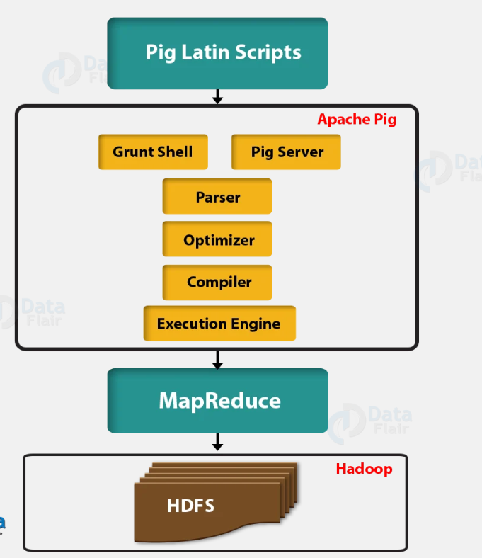
How Pig Works (Architecture)
The architecture consists of a language layer and a runtime layer that work together to process large datasets.
- Pig Latin: A high-level scripting language similar to SQL that describes how data should be loaded, transformed, and stored.
- Grunt Shell: An interactive shell where users can enter Pig Latin commands one by one for immediate feedback.
- Pig Server: The component that accepts Pig Latin scripts and manages their lifecycle through the pipeline.
- Parser: Analyzes the script for syntax errors and generates a Logical Plan (a Directed Acyclic Graph or DAG).
- Optimizer: Reorders operations in the logical plan to improve efficiency, such as early filtering (predicate pushdown) or removing unused columns (column pruning).
- Compiler: Translates the optimized logical plan into a Physical Plan, which is a sequence of MapReduce, Tez, or Spark jobs.
- Execution Engine: Submits the physical jobs to the Hadoop cluster and retrieves the results.

Section 2: Pig Latin Scripting Basics
The Data Model
Pig sees data differently than a standard spreadsheet. Here are the four levels:
- Atom: A single piece of data (e.g., 'Amit' or 45).
- Tuple: A row of data (e.g., (1, 'Amit', 85)).
- Bag: A collection of tuples (like a whole table or a group of rows).
- Relation: The variable name we give to a bag (e.g., student_data = ...).
Syntax Rules & Guidelines
- The Semicolon: Every single statement must end with a semicolon (;).
- Case Sensitivity: * Keywords (LOAD, FILTER, DUMP) are NOT case-sensitive.
  - Field names (name, score) and Relations (student_data) ARE case-sensitive.
- Comments: * -- for a single line.
  - /* ... */ for multiple lines.
Basic Data Types
- int: Whole numbers (e.g., 10).
- float/double: Decimals (e.g., 85.5).
- chararray: Text strings (e.g., 'New York').

Section 3: Installation on Windows 11
Prerequisites
- Java JDK 1.8 (Hadoop and Pig run on Java).
- Hadoop 3.x installed and configured on your machine.
Step-by-Step Installation
- Download: Get the pig-0.17.0.tar.gz file from the official Apache website.
- Extract: Use 7-Zip to extract the files to C:\pig-0.17.0.
- Environment Variables: * Search for "Environment Variables" in Windows.
  - Create a New System Variable: Variable name: PIG_HOME, Variable value: C:\pig-0.17.0.
  - Edit the Path variable and add: %PIG_HOME%\bin.
The "Windows Compatibility" Fix
Pig is built for Linux, so we must fix the startup command for Windows:
- Navigate to C:\pig-0.17.0\bin.
- Right-click pig.cmd and open it in Notepad.
- Find this line: set HADOOP_BIN_PATH=%HADOOP_HOME%\bin
- Change it to: set HADOOP_BIN_PATH=%HADOOP_HOME%\libexec
- Save and exit.

Section 4: Hands-On Demonstration
1. Prepare Sample Data
Open Notepad and create a file named students.txt in C:\hadoopLab\. Paste the following:
Plaintext
1,Amit,85,NewYork
2,Sara,92,London
3,John,78,NewYork
4,Priya,95,Delhi
2. Launch the Grunt Shell
Open your Command Prompt and type:
Bash
pig -x local
Note: -x local tells Pig to use your local files instead of the Hadoop cluster.
3. Running the Script (Sequential Walkthrough)
Step 1: LOAD Tell Pig where the file is and what the columns are.
Code snippet
raw_data = LOAD 'C:/hadoopLab/students.txt' USING PigStorage(',') AS (id:int, name:chararray, score:int, city:chararray);
Step 2: FILTER Let's find only the students who scored above 80.
Code snippet
high_scorers = FILTER raw_data BY score > 80;
Step 3: FOREACH...GENERATE We only want to see names and cities, not IDs or scores.
Code snippet
final_result = FOREACH high_scorers GENERATE name, city;
Step 4: DUMP Pig uses Lazy Evaluation. It hasn't actually touched the data until now. DUMP forces it to work.
Code snippet
DUMP final_result;
4. Troubleshooting Tools
- DESCRIBE final_result;: Shows you the schema (column names and types).
- ILLUSTRATE final_result;: Shows a step-by-step table of how a sample row was transformed.
- EXPLAIN final_result;: Shows the complex MapReduce plan Pig built behind the scenes.

